**AI on PC Reference Implementation: How to Build a Micro Emotion Recognition Solution**

**Introduction**

 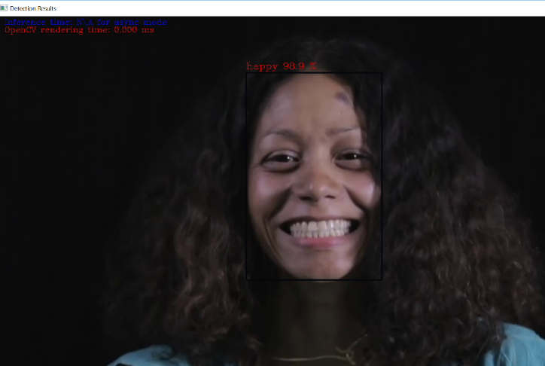

An application capable of recognizing micro emotions from an input video.

## **What it does**

This application is one of a series of AI on PC reference implementations aimed at instructing users on how to develop a working solution for a particular problem. It demonstrates how to create a micro emotion recognition solution using Intel® hardware and software tools. This solution is capable of mapping emptions to five categories - 'neutral', 'happy', 'sad', 'surprise', 'anger’.

## **How it Works**

The model utilizes an inference pipeline of two pre-trained models. The first model in the model stack detects faces in the current input frame. This network is based on a default MobileNet backbone which uses depth-wise convolutions for reducing for the 3x3 convolution block. The model that follows is a full convolutional network which is used for emotion recognition. It identifies emotions on the faces detected and maps it to either of the five categories ('neutral', 'happy', 'sad', 'surprise', 'anger’).

Upon getting a frame from the OpenCV's VideoCapture, the application performs inference with the model stack. The results are displayed in a frame with the detections rendered as bounding boxes, and emotion recognition as text.

**Running the application**

**Step 1. Launch Visual Studio**

To launch Visual Studio, type Visual Studio 2017 in windows explorer and click on the Visual Studio 2017 option

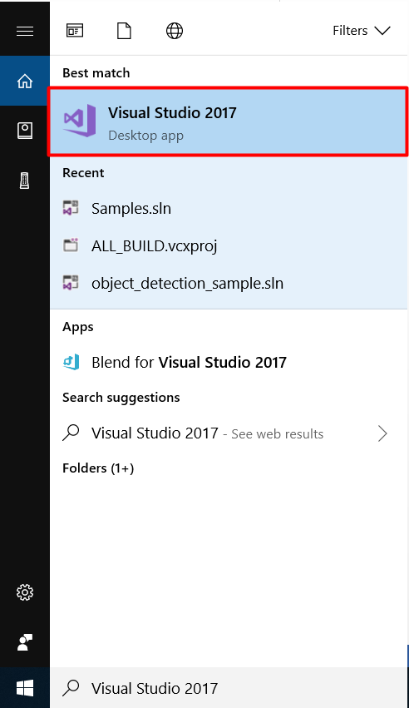

**Step 2. Create a new python project using the existing code in Visual Studio**

1. Choose **File > New > Project …** to create a new project

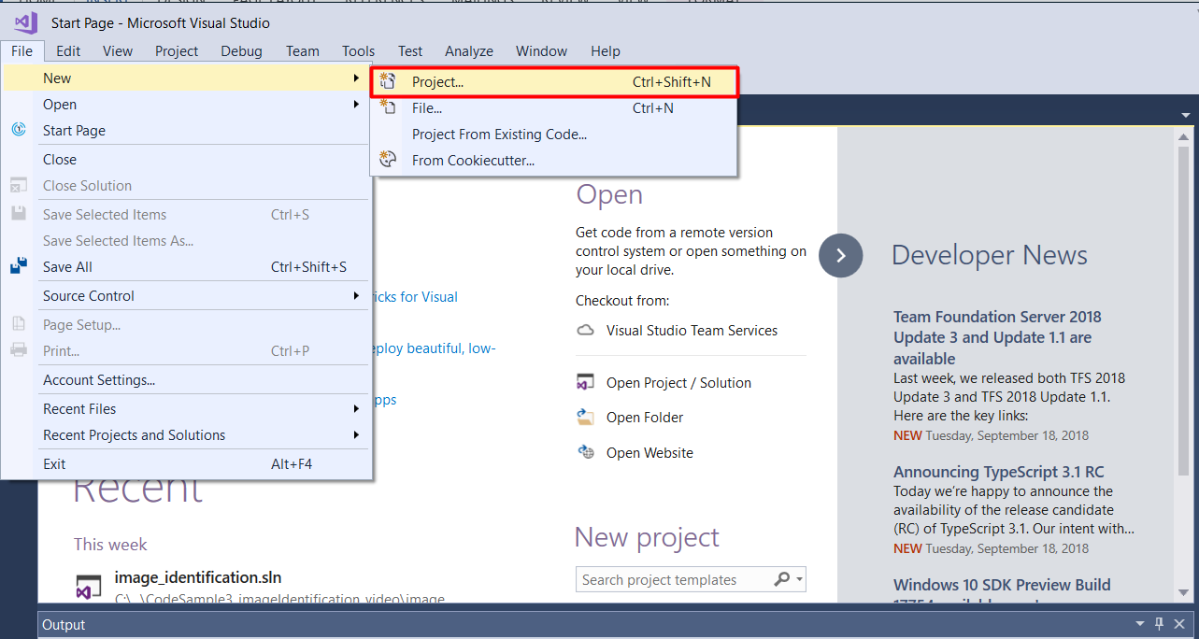

1. You will see a prompt for New Project. Select **Installed > Python > From Existing Python code** from the prompt

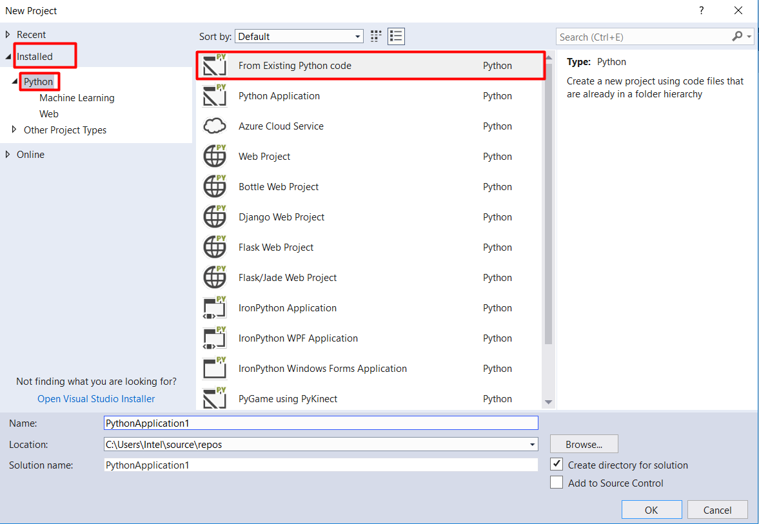

1. Modify the project ‘Name’ and ‘Solution name’ to **microemotion** and click ‘Browse’ button to modify the ‘Location’

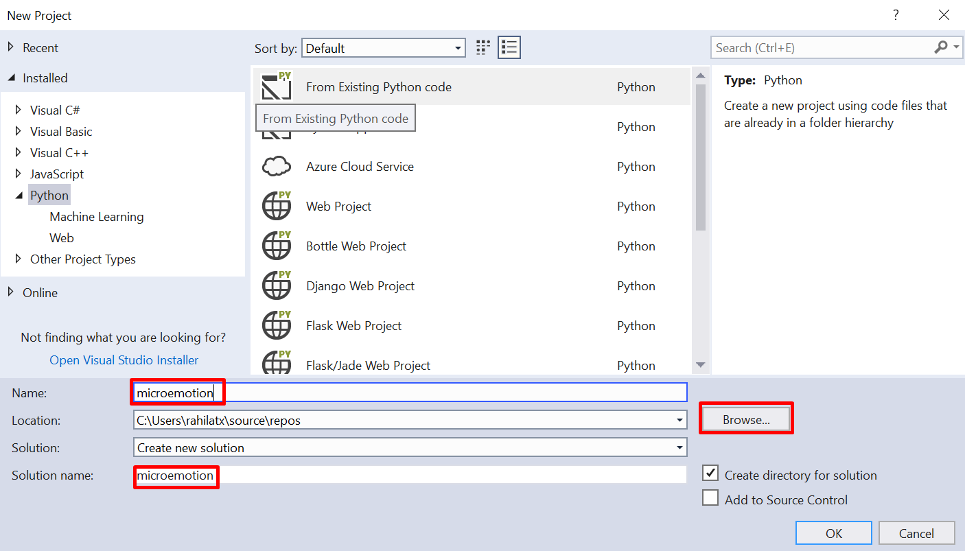

1. Navigate to ‘C:/Intel/AI_on_PC /python_samples/ Tutorial2_MicroEmotion/’, select the microemotion folder and click ‘Select Folder’

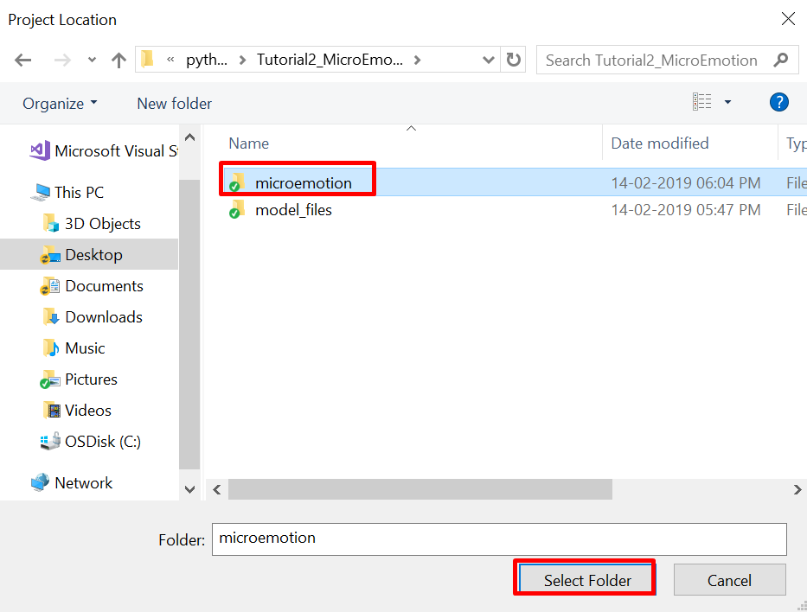

You will see that the location value will now be changed to the microemotion folder

1. Click OK to complete creating the new python project

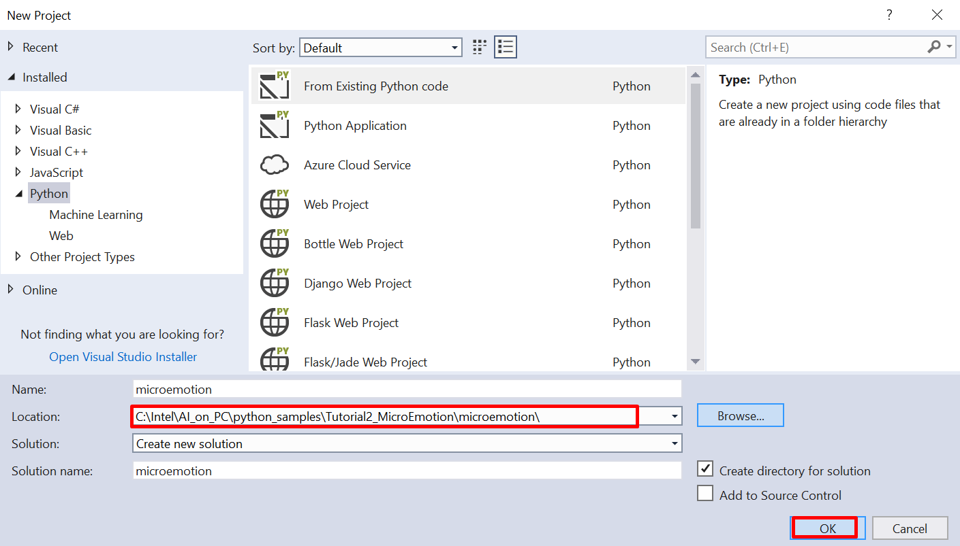

1. After the ‘New Project’ prompt closes, you will see another prompt, ‘Create New Project from Existing Python Code’. The ‘microemotion’ folder contains the python code to be used and will be pre-populated in this prompt. Click Next to select the python file that will be used for the project.

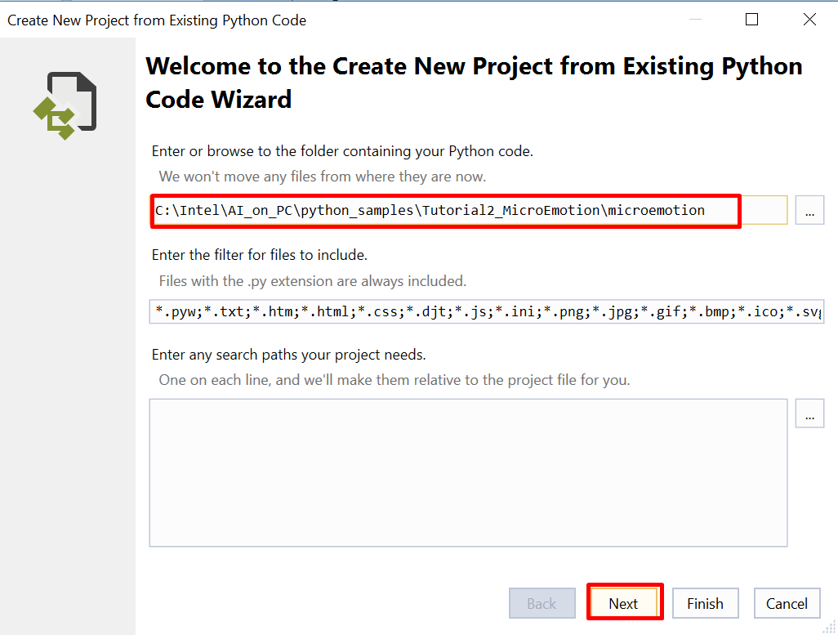

1. Select the ‘microemotion.py’ file and click ‘Next’

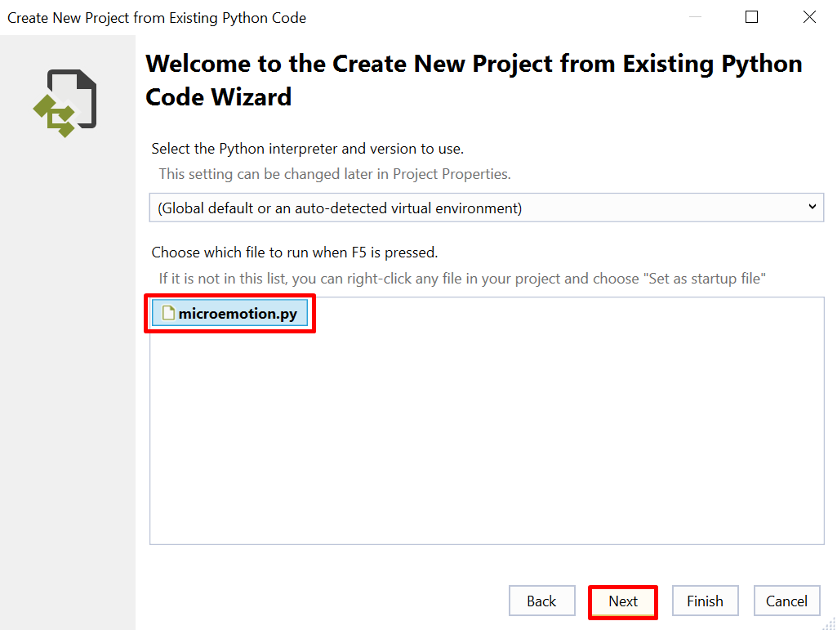

1. Click ‘Finish’ to complete the project creation with the existing python code.

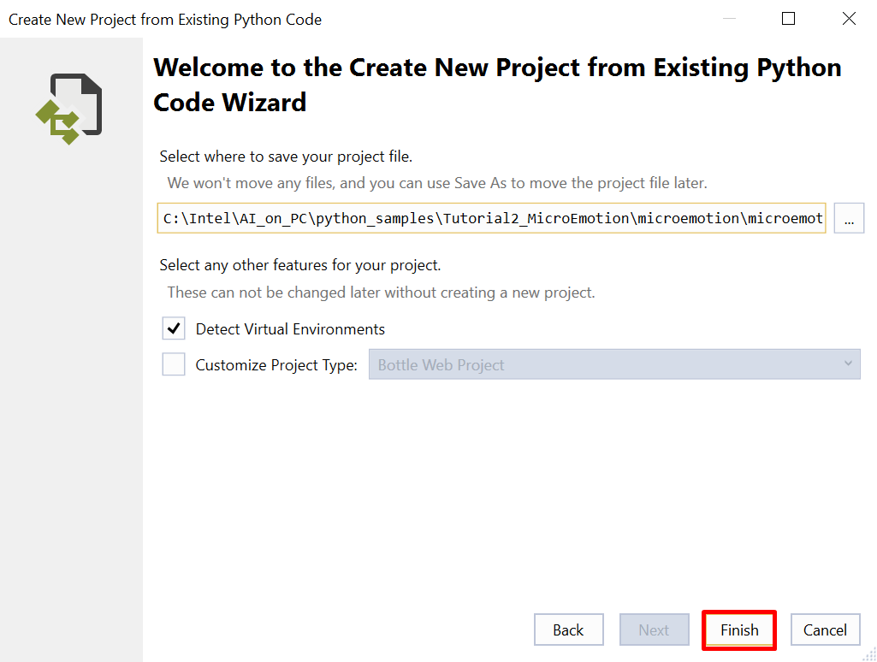

1. The microemotion project will load into the Solution Explorer in Visual Studio

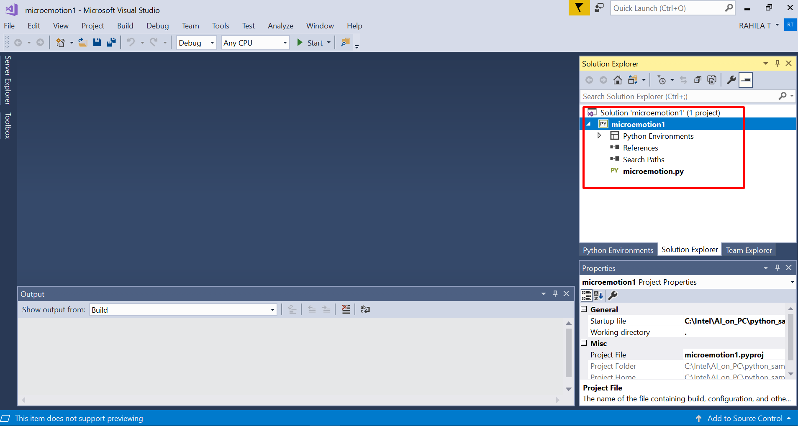

**Step 3. Modify the python file to reflect your python path**

1. Double click the microemotion.py file from the Solution Explorer
2. Modify the <version_number> to reflect the OpenVINO version on your system in the following line of your python code with the version of OpenVINO –

sys.path.append("C:\Intel\computer_vision_sdk_<version_number>\python\python3.6")

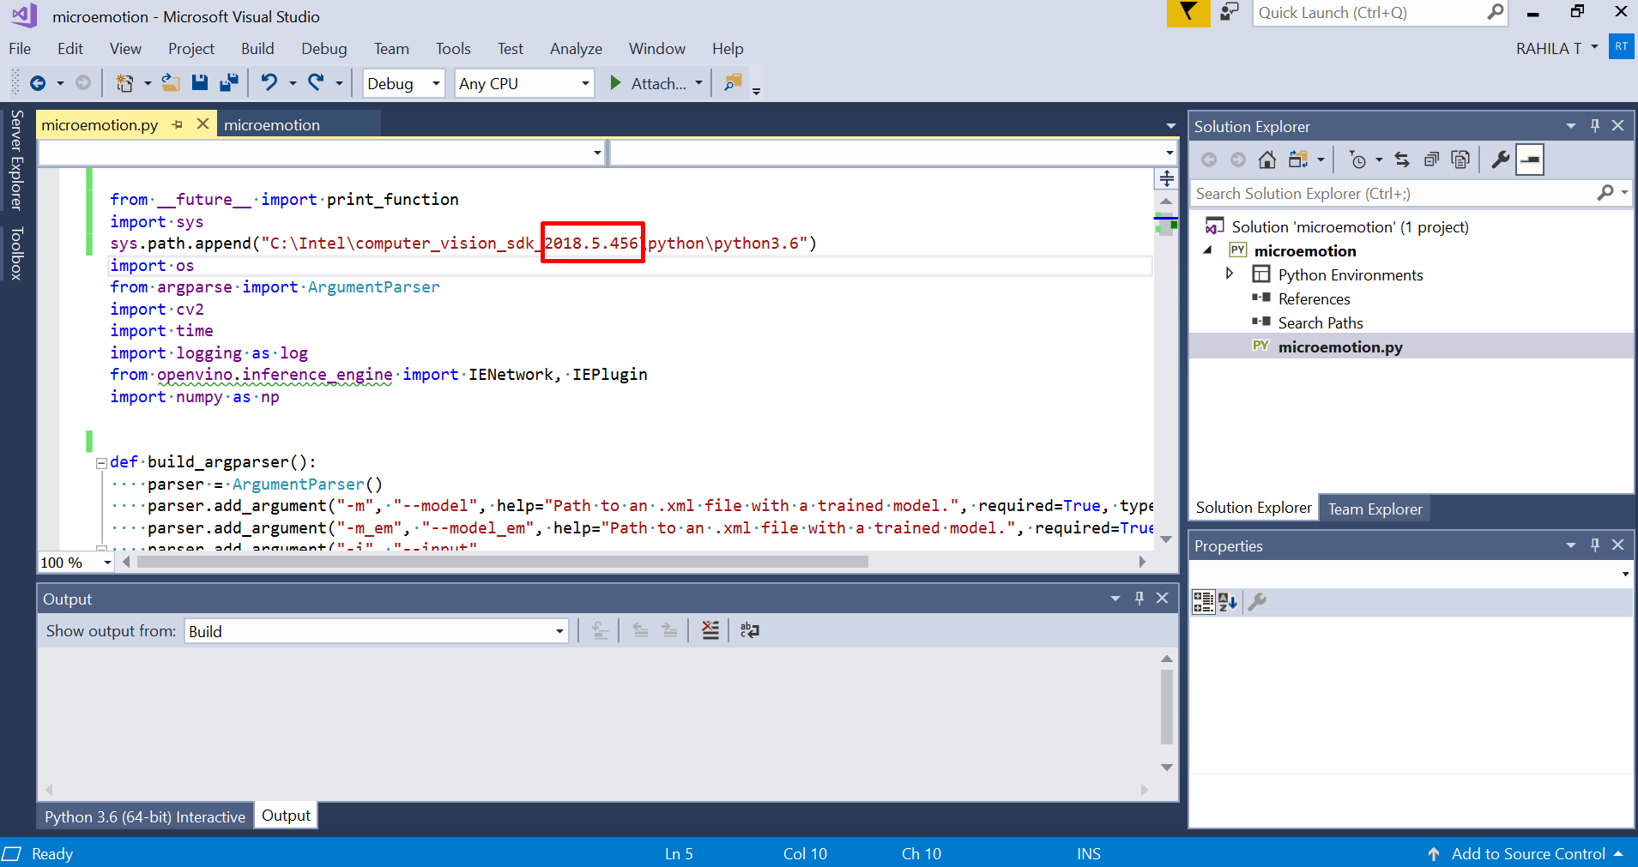

1. Press Ctrl + S from the keyboard to save the changes to the code

**Step 4. Setting up Movidius**

1. Plugin the Movidius Stick into a USB port on your laptop
2. Verify that your laptop has detected the Movidius Stick
   1. Launch Device Manager from the windows explorer

To launch it, type Device Manager in windows explorer and click on the Device Manager option

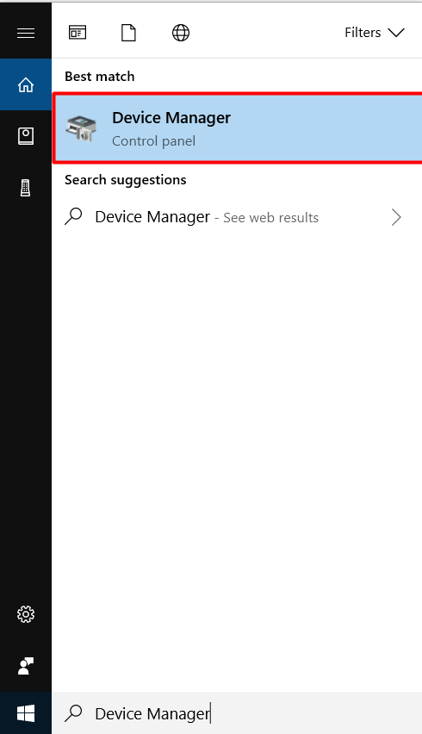

* 1. On the Device Manager screen verify if the option for “Universal Serial Bus devices” is present. If yes, expand the option by clicking the arrow present at its left

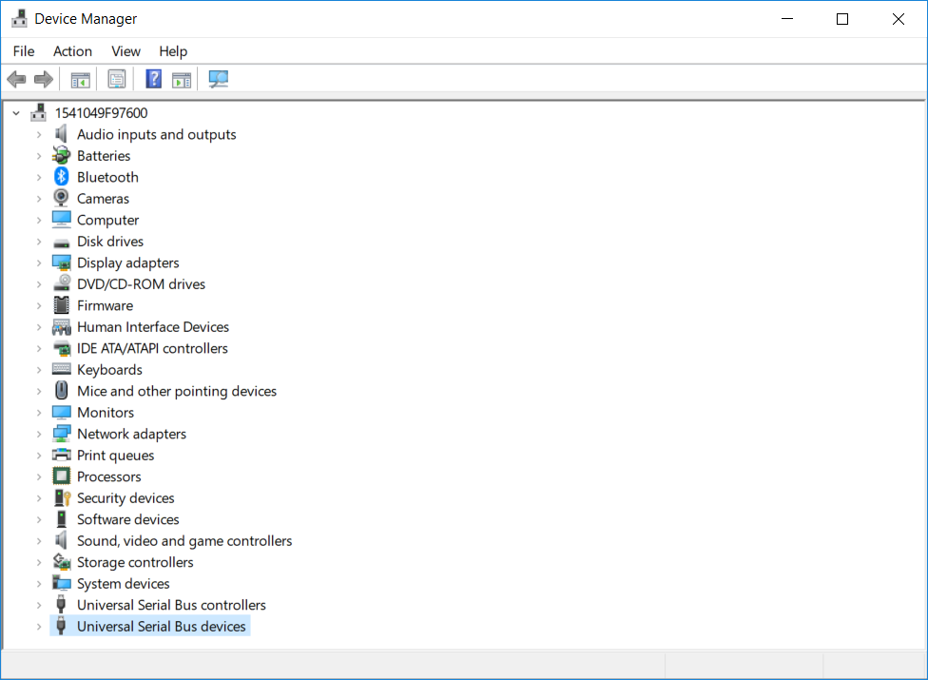

* 1. Verify the option for Movidius MA2X5X in the expanded list

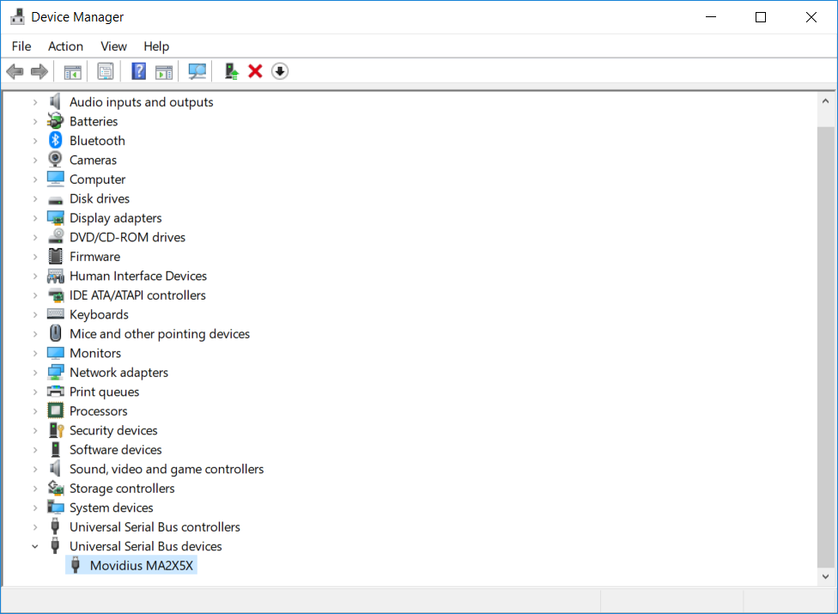

Now that you have made sure that the device is plugged in such that it is getting identified by the system, move back to Visual Studio and continue running the executable.

**Step 4. Run the solution**

1. Right click the microemotion project from the Solution Explorer and click Properties

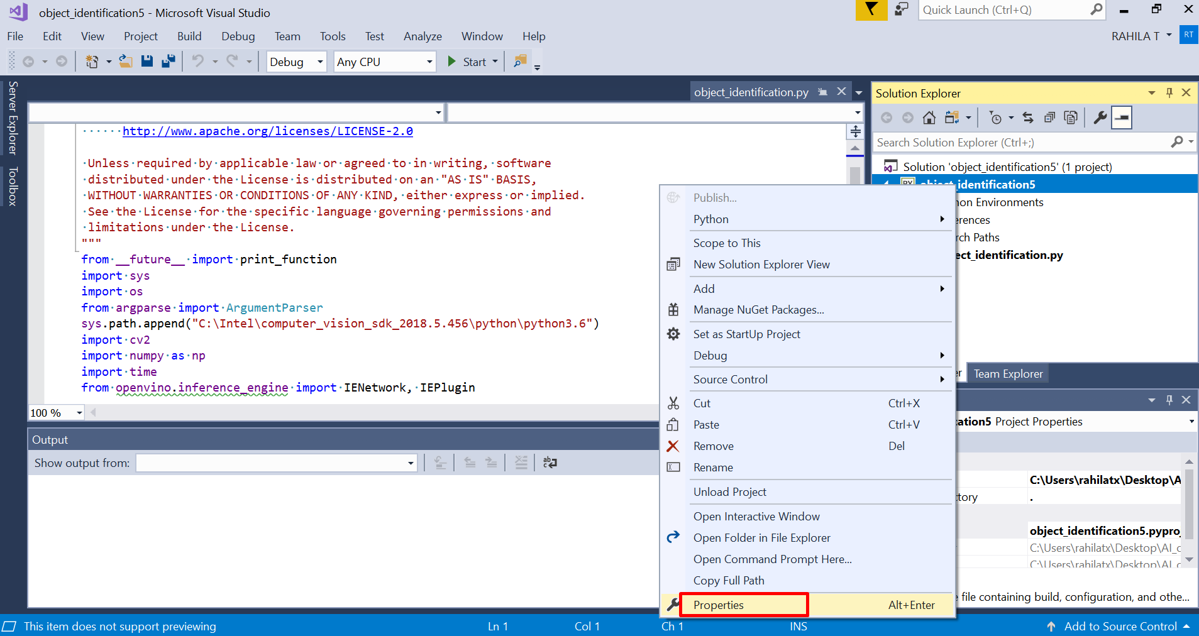

1. The ‘General’ properties for the project opens

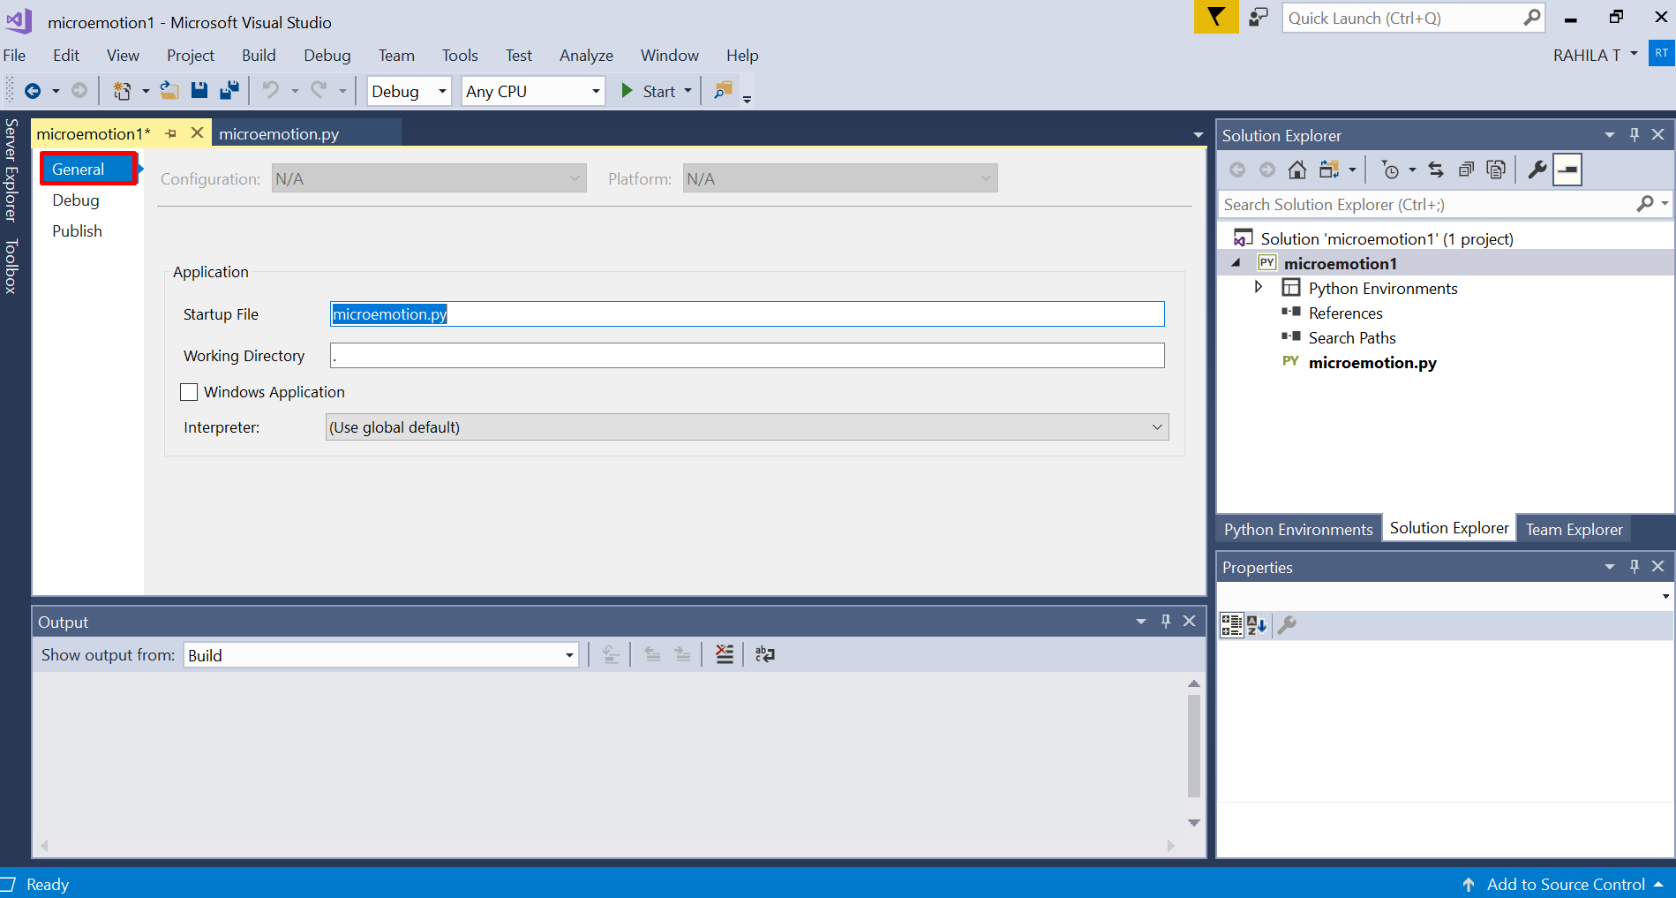

1. Click the ‘Debug’ tab

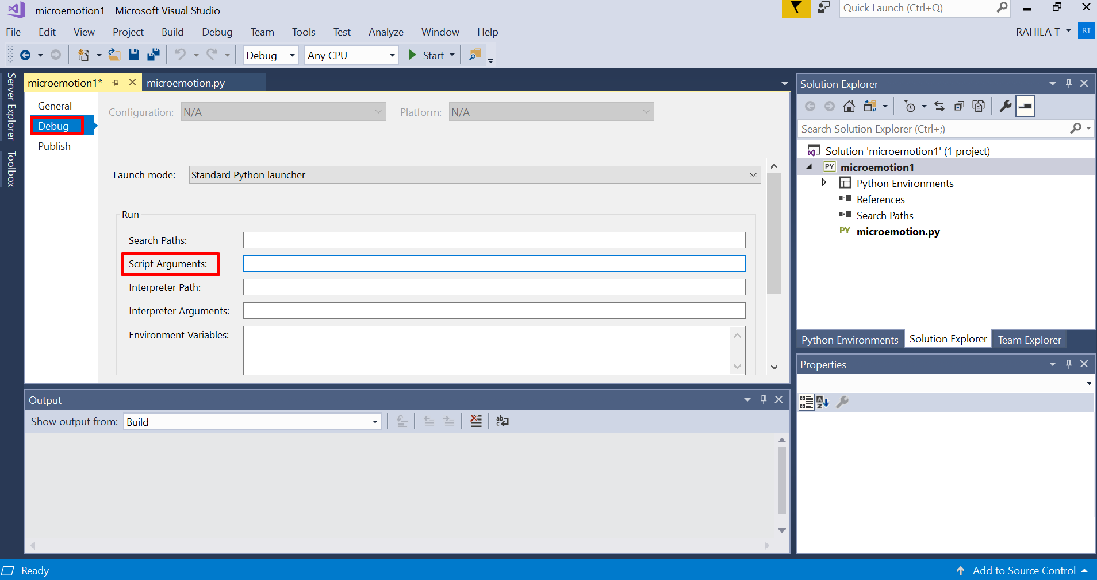

1. Click the text box to the right of ‘Script Arguments’ and enter the following arguments

*-m C:\Intel\AI_on_PC\python_samples\Tutorial2_MicroEmotion\model_files\face-detection-adas-0001\FP16\face-detection-adas-0001.xml -m_em C:\Intel\AI_on_PC\python_samples\Tutorial2_MicroEmotion\model_files\emotions-recognition-retail-0003\FP16\emotions-recognition-retail-0003.xml -i C:\Intel\AI_on_PC\python_samples\Tutorial2_MicroEmotion\model_files\emotions.mp4 -d MYRIAD*

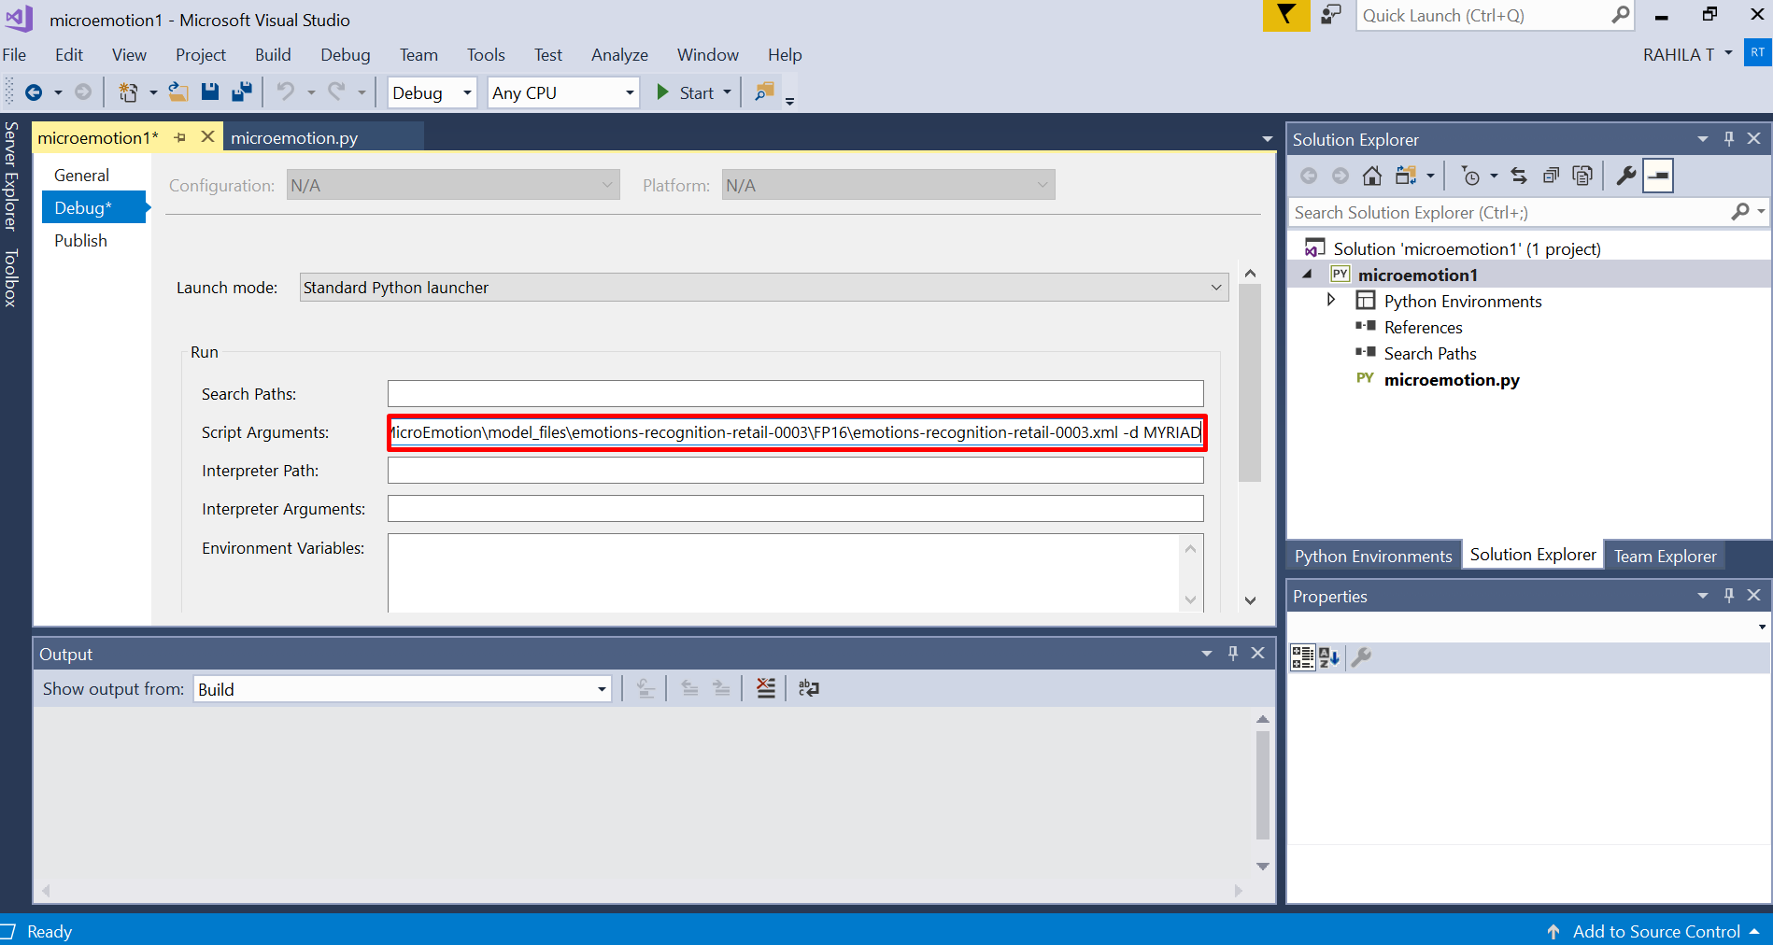

1. Save the changes to the properties by pressing Ctrl + S from the keyboard
2. Press Ctrl + F5 from the keyboard to run the executable with the arguments provided
3. You will be able to see the emotion recognition results in the windows command prompt screen along with the live streaming output

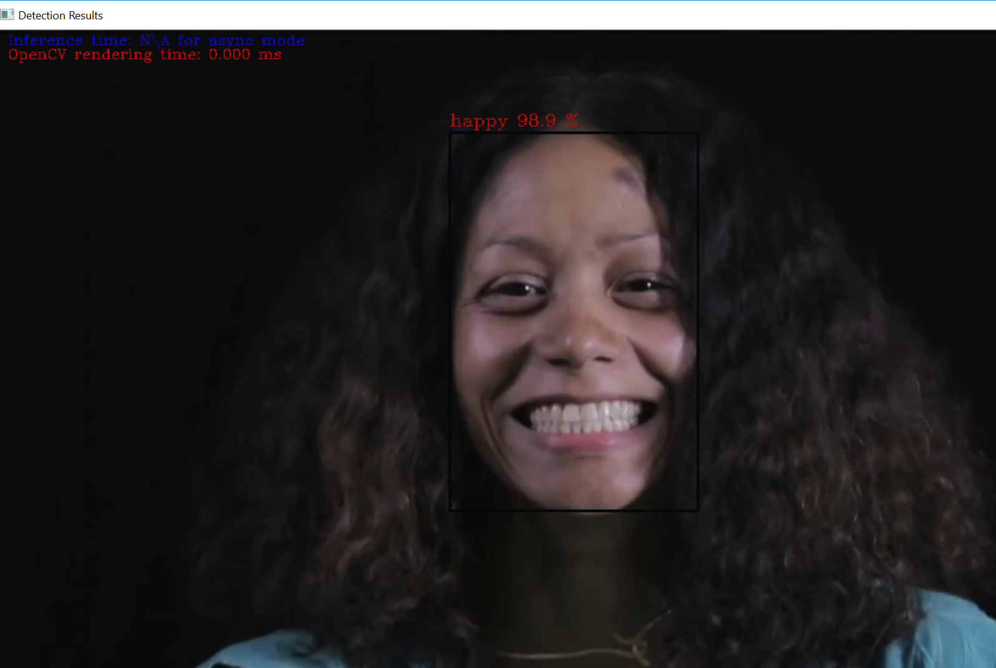

1. Press any key to exit

## **Requirements**

### [Intel® Movidius™ Myriad™ X VPU](https://www.movidius.com/myriadx)

## **Software**

* [Windows](http://releases.ubuntu.com/16.04/) 10
* OpenVINO™